**Microprocessor Lab**

Laboratory Activity No. 3

**Binary Representation of 8 LEDs in TinkerCad and Arduino Programming**

|  |
| --- |
|  |

Score

*Submitted by:*

**Cometa, Leyan Kristoffer P.**

**Saturday (1-4pm) / CPE 0412.1-2**

*Date Submitted*

**14-10-2023**

*Submitted to:*

**Engr. Maria Rizette H. Sayo**

I. Objectives

To create Arduino circuit of Binary representation (decimal 0-255 using 8 LEDs)

II. Method/s

- Perform a task problem given in the presentation.

- Write a code and perform an Arduino circuit diagram of a binary representation of 0 – 255 decimal using 8 LED

III. Results

-This link below is directed to the simulation that was done in the TinkerCad

<https://www.tinkercad.com/things/1itnKs7gONL-binary-representation-of-8-leds/editel?sharecode=TTn8Ky3V1gUJ6pubx1hPBBhB57jqM5s1pt3f2Xu_TR0>

**TinkerCad**

**Exercise 1: Write a code that does a binary representation of 0 -255 using 8 LED that will represent as the 8 bits.**

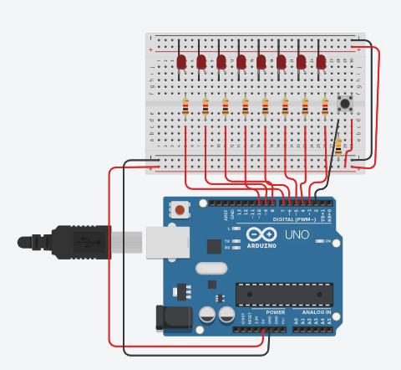

Figure No.1 Ring Counter Display Circuit Diagram

**Components Used**

1. 8 LEDs
2. 8 pcs. of 220 Ω & 1 pc. of 10k Ω Resistor
3. Breadboard
4. 1 pc. of button
5. Jumper wires

**CODE:**

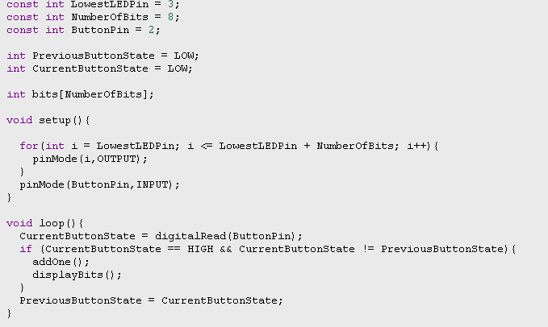

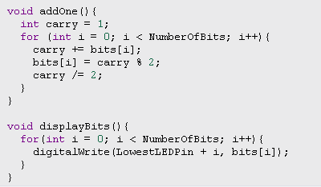

IV. Conclusion

The binary representation using LEDs was made by referring to the existing projects. In the circuit diagram, it can be seen that the LEDs occupied pins 3-10 while the button was connected to pin 2. To check whether the diagram will function, a program was written on it. In the first part, variables for pins, state of the button and number of bits were defined. In the next part which is the void setup, a for loop was used. The for loop tells that the iteration will start at the value of LowestLEDPin and will continue as long as it's less than or equal to LowestLEDPin + NumberOfBits. For every iteration, an output should be produced based on the current bits. The ButtonPin is also been set as INPUT, indicating that it's an input pin to read the state of a button. The third part of the program is the void loop. CurrentButtonState is used to read the current state of the button connected to ButtonPin using digitalRead(). Then, the button is being checked whether it is pressed (i.e., CurrentButtonState is HIGH) and if the button state has changed (i.e., CurrentButtonState is not equal to PreviousButtonState). If both conditions are met, it will call the addOne and displayBits functions. The addOne function is used to increment a binary counter stored in the bits array. It implements a binary addition with carry. Starting with carry set to 1, it iterates through the bits, adding the current bit value and carry, and then updating the bit value and the carry accordingly. The displayBits function is responsible for updating the LEDs to visually represent the binary value stored in the bits array. It uses digitalWrite() to set the state of each LED based on the values in the bits array. With the final result, for every time that the button is pressed, it should output a value within the range of 0-255 decimal in which it can be seen on the state of the LED (1=ON & 0=OFF). To be able to visualize it, decimals must be converted to binary.

**References**

[1] D.J.D. Sayo. “University of the City of Manila Computer Engineering Department Honor Code,” PLM-CpE Departmental Policies, 2020.

[2]P. Marian, “Arduino 8 bit binary led counter,” ElectroSchematics.com, https://www.electroschematics.com/arduino-8-bit-binary-led/ (accessed Oct. 13, 2023).

[3]“CCENT/CCNA ICND1 640-822 official CERT Guide,” O’Reilly Online Learning, https://www.oreilly.com/library/view/ccentccna-icnd1-640-822/9780132660181/app02.html (accessed Oct. 13, 2023).

[4]N. Guluzade, “Arduino binary (8 bit) led’s counter.,” YouTube, https://www.youtube.com/watch?v=HYOsJhSR9S8&ab_channel=NurlanGuluzade (accessed Oct. 13, 2023).